UNSC Resolution: | 925
Date of adoption: | 8 June 1994
Operative paragraph: | 12
Demand number: | 925.1211

Carla Winston

Wording of demand
Take all appropriate steps to ensure the security and safety of the operation and personnel engaged in the operation

List of addressees of the demand
Interahamwe, Government of Rwanda, Rwandan Patriotic Front

Short-term compliance

Description of the addressee(s)’ conduct
7. The former Rwandese political leaders, Rwandese government forces soldiers and militia control the camps, though the degree of control varies from area to area. They are determined to ensure by force, if necessary, that the refugees do not repatriate to Rwanda. They also make it difficult for relief agencies to carry out their work in safety, because they attempt to control the agencies’ activities in the camps and prevent relief supplies from reaching those in need. It is believed that these elements may be preparing for an armed invasion of Rwanda and that they may be stockpiling and selling food distributed by relief agencies in preparation for such an invasion. There have already been some cross border incursions. Security is further undermined by general lawlessness, extortion, banditry and gang warfare between groups fighting for control of the camps. As a result of these threats to security, non-governmental organizations responsible for the distribution of relief supplies in the camps have begun to withdraw.
(Report of the Secretary-General on Security in the Rwandese Refugee Camps, UN Doc. S/1994/1308 (18 November 1994), par. 7)

Assessment

Short-term compliance
No or marginal compliance (1) | Medium low compliance (2) | Medium high compliance (3) | Full or almost full compliance (4)

Considerations underlying the assessment

No reports of incidents directed at UN personnel inside Rwanda and a general prevalence of calm and lack of armed conflict inside the country point to at least medium-high compliance by the RPF and Government of Rwanda as it was after July 18. While security in the camps for relief personnel was not the best, due to actions of the former Government of Rwanda and Interahamwe, there are no reported incidents of overt violence toward personnel.

Medium-term compliance

Description of the addressee(s)’ conduct
16. The threat to the safety of international relief workers is also significant. There are now 45 non-governmental organizations (NGOs) and about 1,600 international relief workers in the Goma area alone. A large number of local Zairian and Rwandese relief personnel also work in the camps. The security threat to these relief workers includes harassment, especially on their way to and from the camps when they are frequently stopped, in some cases at gunpoint, and asked to pay tolls or are threatened for other reasons. There is also a significant risk that relief workers can be caught up in civil disturbances or incidents between refugees themselves. Some relief workers have been threatened by refugees who for some reason wrongly perceive them to be opposed to their interests.
(Second Report of the Secretary-General on Security in the Rwandese Refugee Camps, UN Doc. S/1995/65 (25 January 1995), par. 16-17)

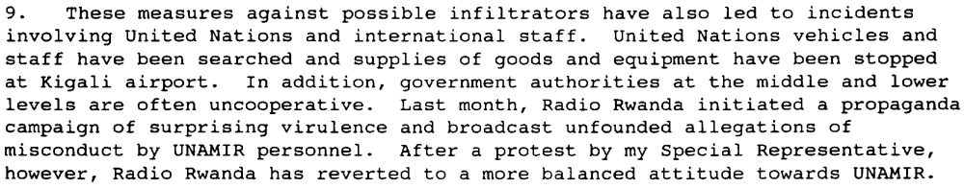
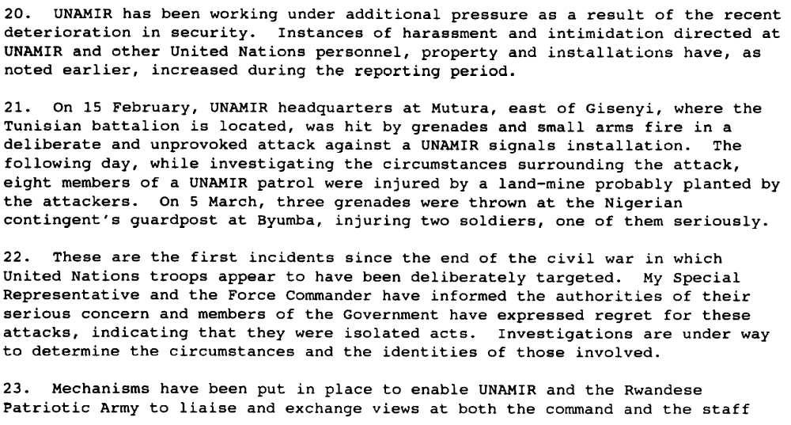(Progress Report of the Secretary-General on the United Nations Assistance Mission for Rwanda, UN Doc. S/1995/297 (9 April 1995), par. 9, 20-22)

Assessment

Medium-term compliance
No or marginal compliance (1) | Medium low compliance (2) | Medium high compliance (3) | Full or almost full compliance (4)

Considerations underlying the assessment
Interahamwe did not take steps to ensure safety, and within Rwanda decreasing security of UN personnel concluding in general harassment and a few specific incidents of violence towards UN personnel

Depth of demand

Assessment

Level of depth of demand
Low depth of demand (1) | Medium depth of demand (2) | High depth of demand (3)

Considerations underlying the assessment

For the Interahamwe and pre-July 1994 Government of Rwanda, taking steps to ensure UN personnel safety would have hindered their ability to keep or regain control over the populations around them. For the RPF and post-July 1994 Government of Rwanda, security concerns related to the need to deal with internal opposition and incursions from Zaire were apparently more important to the RPF/Government’s power than the need to comply with UN demands.

Level of confidence about coding decisions

Level of confidence about coding decision
Extremely high | High | Moderate

Comments to IPI (if any)
General lack of sources in the short term relating to conditions for UN personnel inside Rwanda.

UNSC Resolution: | 925
Date of adoption: | 8 June 1994
Operative paragraph: | 12
Demand number: | 925.1212

Carla Winston

Wording of demand
Extend the security and safety arrangements to all persons engaged in the operation

List of addressees of the demand
Interahamwe, Government of Rwanda, Rwandan Patriotic Front

Short-term compliance

Description of the addressee(s)’ conduct
7. The former Rwandese political leaders, Rwandese government forces soldiers and militia control the camps, though the degree of control varies from area to area. They are determined to ensure by force, if necessary, that the refugees do not repatriate to Rwanda. They also make it difficult for relief agencies to carry out their work in safety, because they attempt to control the agencies’ activities in the camps and prevent relief supplies from reaching those in need. It is believed that these elements may be preparing for an armed invasion of Rwanda and that they may be stockpiling and selling food distributed by relief agencies in preparation for such an invasion. There have already been some cross border incursions. Security is further undermined by general lawlessness, extortion, banditry and gang warfare between groups fighting for control of the camps. As a result of these threats to security, non-governmental organizations responsible for the distribution of relief supplies in the camps have begun to withdraw.
(Report of the Secretary-General on Security in the Rwandese Refugee Camps, UN Doc. S/1994/1308 (18 November 1994), par. 7)

Assessment

Short-term compliance
No or marginal compliance (1) | Medium low compliance (2) | Medium high compliance (3) | Full or almost full compliance (4)

Considerations underlying the assessment

No reports of incidents directed at UN personnel inside Rwanda and a general prevalence of calm and lack of armed conflict inside the country point to at least medium-high compliance by the RPF and Government of Rwanda as it was after July 18. While security in the camps for relief personnel was not the best, due to actions of the former Government of Rwanda and Interahamwe, there are no reported incidents of overt violence toward personnel.

Medium-term compliance

Description of the addressee(s)’ conduct
16. The threat to the safety of international relief workers is also significant. There are now 45 non-governmental organizations (NGOs) and about 1,600 international relief workers in the Goma area alone. A large number of local Zairian and Rwandese relief personnel also work in the camps. The security threat to these relief workers includes harassment, especially on their way to and from the camps when they are frequently stopped, in some cases at gunpoint, and asked to pay tolls or are threatened for other reasons. There is also a significant risk that relief workers can be caught up in civil disturbances or incidents between refugees themselves. Some relief workers have been threatened by refugees who for some reason wrongly perceive them to be opposed to their interests.
(Second Report of the Secretary-General on Security in the Rwandese Refugee Camps, UN Doc. S/1995/65 (25 January 1995), par. 16-17)

(Progress Report of the Secretary-General on the United Nations Assistance Mission for Rwanda, UN Doc. S/1995/297 (9 April 1995), par. 9, 20-22)

3. … The prospect of the UNAMIR withdrawal after 8 March 1996 has also caused representatives of some international organizations in Rwanda to express concern about their safety, in particular after the expulsion of 38 non-governmental organizations and an incident, albeit isolated and immediately acted upon by the Government, in which three members of the International Tribunal were assaulted by a Rwanda Patriotic Army (RPA) guard unit.

(Report of the Secretary-General on the United Nations Assistance Mission for Rwanda, UN Doc. S/1996/149 (29 February 1996), par. 3)

Assessment

Medium-term compliance
No or marginal compliance (1) | Medium low compliance (2) | Medium high compliance (3) | Full or almost full compliance (4)

Considerations underlying the assessment
Interahamwe did not take steps to ensure safety of relief personnel, and within Rwanda decreasing security of related to frustration at UNAMIR most likely led to decreased security of non-UNAMIR personnel, such as the attack upon Tribunal staff.

Depth of demand

Assessment

Level of depth of demand
Low depth of demand (1) | Medium depth of demand (2) | High depth of demand (3)

Considerations underlying the assessment

For the Interahamwe and pre-July 1994 Government of Rwanda, taking steps to ensure personnel safety would have hindered their ability to keep or regain control over the populations around them. For the RPF and post-July 1994 Government of Rwanda, security concerns related to the need to deal with internal opposition and incursions from Zaire were apparently more important to the RPF/Government’s power than the need to comply with UN demands.

Level of confidence about coding decisions

Level of confidence about coding decision
Extremely high | High | Moderate

Comments to IPI (if any)
General lack of sources in the short term relating to conditions for UN or humanitarian personnel inside Rwanda.

